India’s Infrastructure Development for Military Preparedness: An Overview
Major General Brajesh Kumar (Retd), AVSM, VSM

Byline:
All major civil infrastructure development within the country supports the military directly or indirectly by boosting the supply chain and supporting the security matrix. As an emerging international power, this aspect assumes greater importance.

Geography and terrain form the bedrock of geopolitics, dictating strategic depth, defensive bottlenecks, and logistical realities that nation-states must navigate. From protecting borders to projecting power, physical landscapes inevitably shape and constrain national security doctrines across eras. The Himalayas have historically provided the Indian subcontinent with an impenetrable northern boundary, influencing historical defensive posturing and allowing distinct regional cultures to flourish. It also provided a massive geographic shield, directing monsoon patterns and blocking freezing Siberian winds to regulate India's climate. Meanwhile, maritime access to ports and control of maritime choke points have dictated economic resilience and naval security. The Cholas and Pandyas built formidable maritime networks across the Indian Ocean, utilizing their Navies for trade, diplomacy, and military supremacy.

Post-Independence
Chinese offensive in Ladakh and Arunachal Pradesh (NEFA then) in 1962 came as a rude shock, India was unprepared militarily and lacked physical infrastructure like roads & tracks in Operations area, bridges (No bridge existed over rivers Ganga east of Varanasi and on R Brahmaputra), Air Infrastructure (IAF not deployed for Air Ops), Ammunition Depots, Habitation, Storage accommodation and Utility Services in difficult terrain and weather conditions. For the Indian Politico-Military establishment, this was a wake-up call, and major restructuring of the Armed Forces followed, as subsequent conflicts with Pakistan in 1965 and later in 1971 prove. However, during the Kargil Ops, Doklam and Galwan incidents, more recently, inadequacies were noticed in infrastructure at strategic, operational, and tactical levels. With resources heavy and long gestation period to build, infrastructure is important and the 4th pillar of modernisation of the Armed Forces next to manpower development, armaments & munitions systems, and doctrinal framework.

India has territorial disputes and long, unsettled borders with both its adversaries, which continue to suck a large amount of scarce resources. Out of India’s 15106.7 km land borders, 3488 km of the Line of Actual Control (LAC) with China and 890 km of the Line of Control (LOC) & Actual Ground Position Line (AGPL) with Pakistan are under dispute. India has a maritime boundary dispute at Sir Creek with Pakistan. China and India remain long-term competitors and principal adversaries. A greater thrust in building infrastructure is needed along the LAC. The terrain and weather on the Indian side of the border entail a higher degree of friction for construction. India has given a push to infrastructure developments along the LAC, which it had ignored due to a defensive mindset. China’s infrastructure is exceedingly well developed.
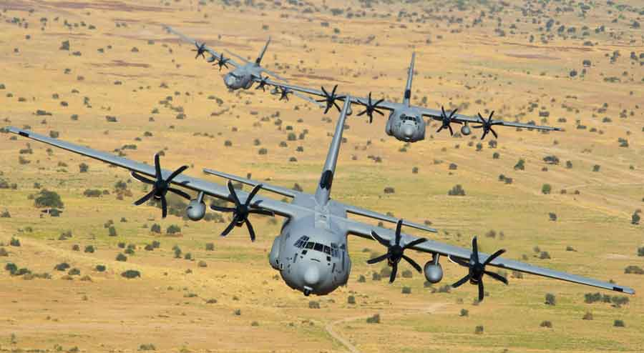
C130J Super Hercules over Himalayas,
Source : swarajyamag.com

Ladakh
The land of high passes is a high-altitude cold desert with towering mountain ranges, deep gorges, and an elevated plateau averaging 3500 m altitude. Supporting the Indian Armed Forces post-Galwan crisis posed significant challenges with limited road connectivity on both axes, which are closed during the winter months. A greater thrust to improve road connectivity, tunnelling, habitation, provision of utilities, and air assets has been given now. Some focus areas -

Strategic Roads
Conversion of Jammu – Srinagar Highway to four lanes.
Enhancement of the Srinagar - Leh Axis to provide year-round connectivity. Construction of six tunnels and other major improvements is underway.
- Creation of Z- Morh tunnel - 6.5 km now operational
- Construction of Zozi La tunnel -14.2 km with projected date of completion by Feb 2028
- Nilgrar Tunnels - Construction of 3 small tunnels close to Zozi La
- Fotu La Tunnel - 2.65 km bypassing weather-sensitive stretches
Massive infra upgrades on the Manali - Leh Axis - Conversion of a 427 km long highway to provide all-weather year-round connectivity, by creating a large number of tunnels for winter accessibility with snow clearance.
- Atal Tunnel – 9.02 km operational
- Shunku La Tunnel – under construction
Four additional major tunnels at Baralacha La, Lchulung La, Nakki La, and Tanglang La are being planned by the BRO.
Additional Road Network in Eastern Ladakh – constructed/ under construction to enhance military preparedness.
- Sasoma – Daulat Beg Oldi road, 130 km all-weather roads link the Nubra valley with Daulat Beg Oldie (DBO), which is of strategic importance and provides an alternate route to DBO.
Critical lifelines for military & logistics along the LAC are provided by connectivity to remote border villages of Chumar, Demchok, and DBO. A few roads are given below:
- Darbuk-Shyok-Daulat Beg Oldie (DS-DBO) Road
- Likaru-Mig La-Fukche Road
- Umling La Road
- Hanle-Chumar Road Indian Astronomical Observatory has been established at Hanle
- Chushul-Dungti-Fukche-Demchok Axis
- Karu-Tangtse-Lukung Road

Other Infrastructure Projects in Ladakh
Air facilities have seen rapid acceleration by operationalisation of strategic airfields and supporting services.
Mudh - Nyoma Airbase is the third air base at 13700 ft created in Ladakh (alongside Leh and Thoise), merely 30 km from the LAC, with capabilities of operations in winter.
Advanced Landing Grounds (ALGs) at DBO and Fukche have been upgraded to support medium-lift and tactical fixed-wing aircraft like the C-130J Super Hercules.
Simultaneously, improvements for the habitation of troops, utility services, and shelters for Guns, Tanks, Radars, armament munitions, and many others are being undertaken.
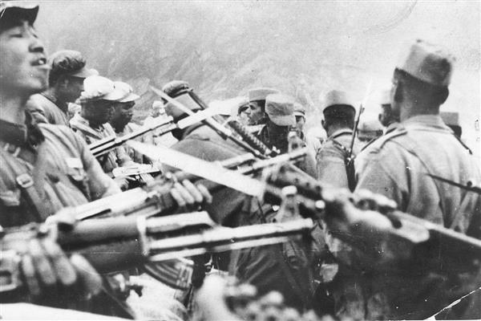Chinese offensive 1962
Source : upscwithnikhil.com

Arunachal Pradesh
The northeastern frontier state has an equally complex topography with rugged mountainous terrain, deep valleys, and dense expansive forests. From sub-tropical Brahmaputra plains in the south to the snow-capped peaks of the outer Himalayas at the watershed. Very heavy rainfall impedes infrastructure projects. India is rapidly upgrading military and border infrastructure to ensure all-weather connectivity along the Line of Actual Control.

Infrastructure Upgrades
Construction of two major tunnels on the BCT (Balipara – Charduar – Tawang) Road at Sela (twin tunnel at 13000 feet) & Niche Phu to provide all-weather connectivity to LAC in the Kameng sector. Improvements to roads and tracks along the LAC are being undertaken. Advanced Landing Grounds (ALGs) - Facilities of Tawang Air Force Station are upgraded, and the improvement of seven ALGs at Menchuka, Daporijo, Along, Tuting, Pasighat, Walong, and Vijaynagar can operate heavy military transport aircraft for Air Ops and logistics.
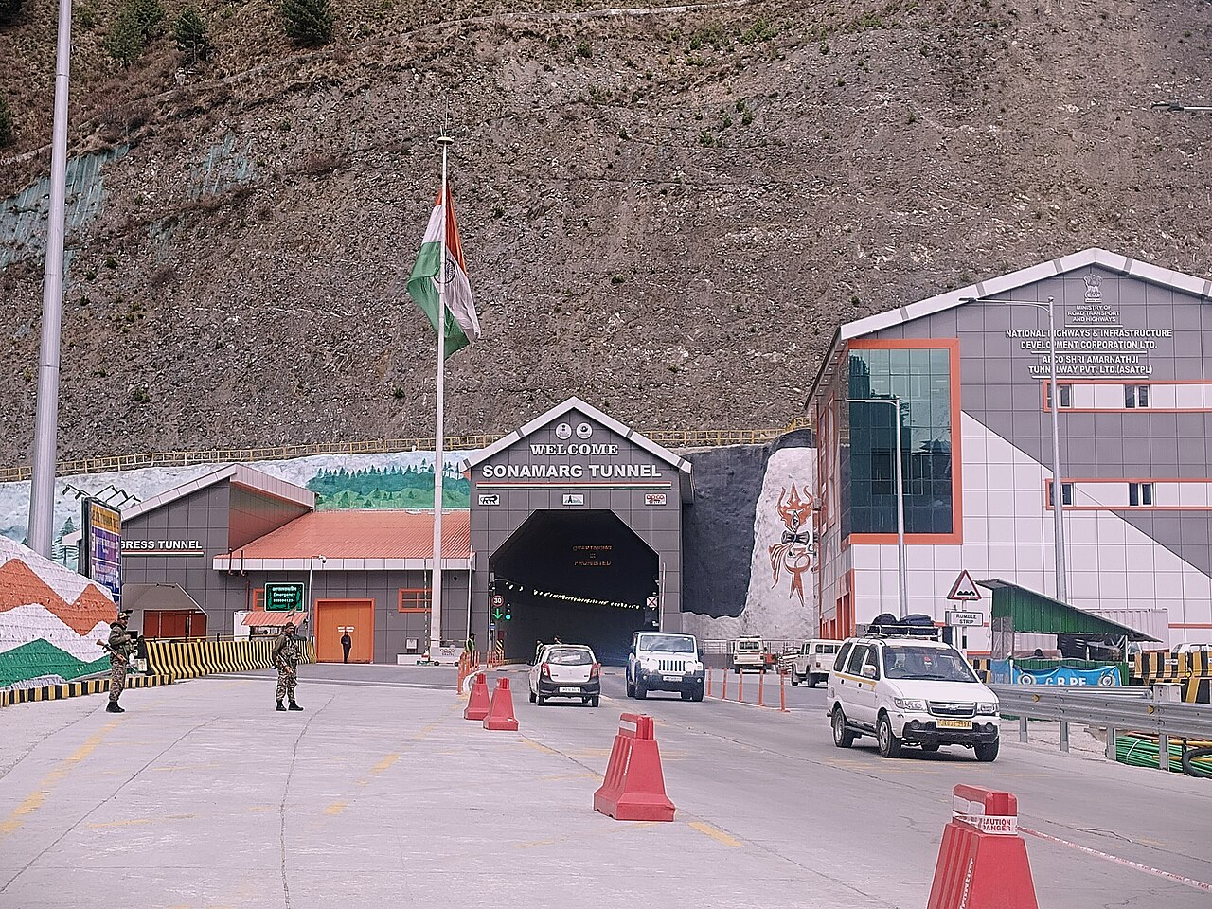Z-Morh Tunnel, Jammu and Kashmir, India
Image Source : wikipedia.org
Sikkim
Construction of the Sevoke - Rangpo railway line will connect Sikkim with the national railway grid and improve transportation. Upgrading strategic routes, such as NH-717B, and the proposed network of the Bagdogra - Gangtok Expressway will reduce travel times. Moreover, the construction of a robust network of roads/ALGs drastically enhances mobility and thereby the war-ranging capability of the Armed Forces, especially during the harsh winter months, when passes are closed.

Securing Other Critical Choke Points
Siliguri Corridor
The narrow corridor linking India’s Northeast to its mainland is a potential vulnerability, with a narrow 22 km width; the entire road, railway, energy and communication links to Assam and other Northeastern states pass through this corridor. With a porous border and the movement of illegal people, the security threat remains high. A few remedial measures under consideration are already under consideration - (i) Creation of UG Railway Tunnel for secure communication along the corridor, through which the railway lines, gas pipelines, and optical fibre cables can securely pass; (ii) the creation of Tetuliya Corridor, a 4 to 6 km passage through Bangladesh’s Tetuliya Upazila; and, (iii) Kaladan Multimodal Transit Transport Project, as it offers Northeast India an alternative route to the sea, through Myanmar.
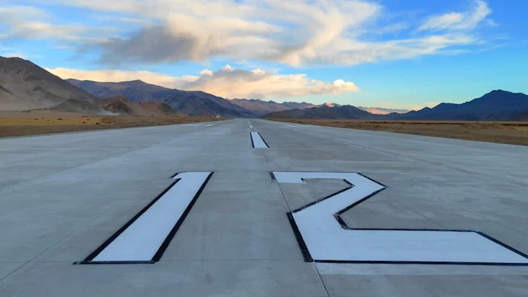 Mudh - Nyoma Air base, Ladakh, India
Source : indiatoday.in

Andaman Nicobar Islands
India’s Bay of Bengal archipelago is geographically important and is one of the nation’s strategic assets. Andaman and Nicobar Command (ANC) is the only operational geographic tri-service command, akin to an unsinkable Aircraft carrier with four operational airfields at Diglipur in the north, Sri Vijay Puram (Port Blair), Car Nicobar, and Campbell Bay in the south. The archipelago is important for India’s growing strategic concerns, useful for sea domination of the Indo-Pacific arena and sea denial of the Bay of Bengal/Indian Ocean. Appropriately located near the Malacca Strait, it adds heft to India’s prosperity and maritime security and serves as India’s gateway to Southeast Asia. More importantly, it dominates the three sea lanes and the choke points of the 6 and 10 Degree Channels and the Duncan Passage. India plans to develop the ANC Islands into a formidable Strategic Military Base. Recently announced, the Campbell Bay project is just the beginning.
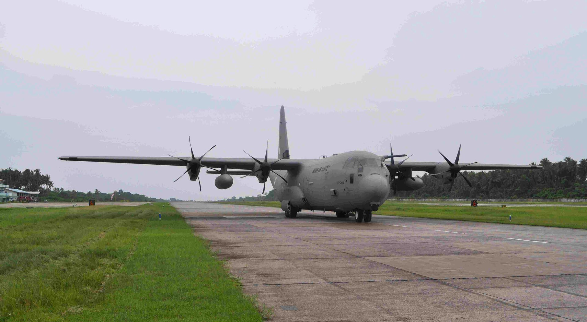
C130J Super Hercules Landing in Car Nicobar Airbase
Source : wikipedia.org

Military Infrastructure in Support of Military-Diplomatic Initiative
A few infrastructure projects were/are constructed in friendly foreign countries to support our military base(s) or as part of Defence Cooperation. The Indian Army has a training team placed in Bhutan and a Border Roads Organisation project to maintain strategic and operational roads. An Air Force base at Ayni (Tajikistan) was established at Dushanbe, which served as India’s first overseas base. India is in the process of establishing a strategic air force and naval presence at the Agalega Islands, situated north of Mauritius.

Military Satellite & Surveillance Capability
This is a force multiplier in modern wars and would continue to be of greater relevance in the future as well. Creation of battlefield transparency to negate the fog of war is being leveraged extensively in the ongoing global conflicts occurring in Eastern Europe and West Asia. Operation Sindoor lessons would be relevant as well. India is rapidly expanding its military satellite surveillance capabilities with the Space-Based Surveillance (SBS) project to deploy 52 dedicated Military Satellites by 2029. This constellation aims to provide the Indian Armed Forces with 24/7, all-weather monitoring with rapid revisit times across the target zones.

India’s Defence Space Agency operates a multi-layered approach to space-based Intelligence, Surveillance, and Reconnaissance (ISR) capability. The architecture includes the provision of Radar Imaging Satellites (RISAT), Cartosat Series Earth observation Satellites, and Hyperspectral Imaging to detect and relay intelligence on potential threats from staging areas deep within adversary territory. The strategic focus remains India’s borders with China, Pakistan, the Indian Ocean region, and ensuring space deterrence.

Civil Infrastructural Developments
Border Fencing
To stop illegal immigration, smuggling, and drug trafficking, India had to undertake massive border fencing along with the creation of parallel road/track and lighting arrangements along the international boundaries with all our neighbours other than Nepal and Bhutan.

National Logistics Upgrades
The PM GatiShakti National Master Plan (PMGS-NMP), a multi-modal connectivity infrastructure, is transformative for economic growth & sustainable development. The focus on improvement in Railways, Roads, Ports, Waterways, Airports, Mass Transport & Logistics infrastructure will reduce logistics cost tremendously. Implementation will aid the security and military apparatus by significantly enhancing logistics and the supply chain. Linking the industrial hinterland to the border area and new highways, where fighter aircraft can land in emergencies, would be very useful.
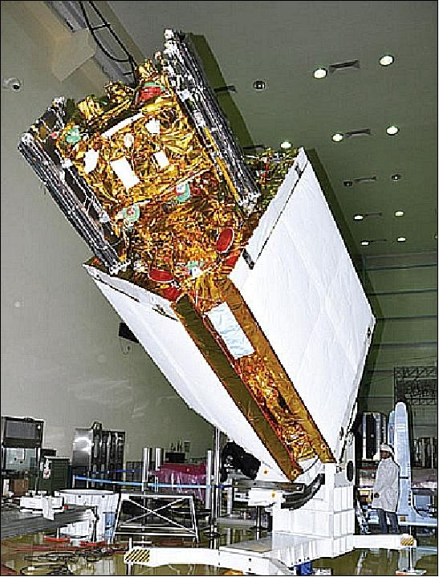RISAT Satellite Source : eoportal.org

Deep Water Ports
Maritime connectivity provides a lifeline for trade and commerce. India’s Blue Water Economy gets a boost with the development of three major greenfield ports with a draft of over 20 meters under planning and execution. Vizhinjam International Seaport (Kerala) is India’s first deep-water dedicated container transhipment port, strategically located 10 nautical miles from major international east - west shipping routes. Vadhavan Port (Maharashtra), a greenfield project, is under development for large container ships exceeding 24,000 TEUs. Galathea Bay (Andaman and Nicobar Islands), an International Container Transhipment Terminal (ICTT), is being developed to capture critical transhipment traffic from Singapore. Malaysia and Colombo, located close to the 6-degree channel.
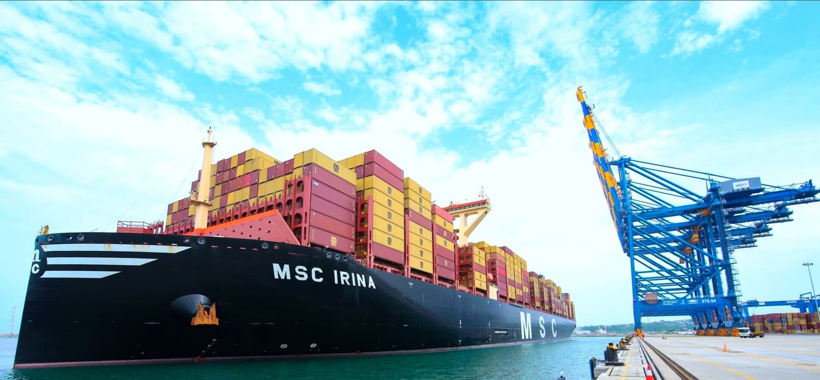
Vizhinjam or Trivandrum Seaport
Image Source : wikipedia.org

New IAF Bases
Two additional IAF bases are under planning: one at Daesa (Gujarat) to plug operational voids, and the second at Khajuraho, a hub for rapid deployment of fighter and logistics aircraft.

Civil Aviation
India is aggressively expanding its aviation capacity from 160 presently operational airports to its vision of reaching 350-400 airports by 2047. Major urban expansion, regional connectivity, and advanced technological upgrades will help. Navi Mumbai and Jewar (Greater Noida) are two Civil Aviation International Airports that have recently been commissioned.

Security of Data
Undersea cables carry nearly 99% of international digital data and communications. India’s concerns centre on route concentration, chokepoint vulnerabilities like the Straits of Hormuz and Bab el-Mandeb, and the risk of physical sabotage or espionage. Disruptions threaten the nation’s financial systems, military communications, and IT/BPO sectors. New and additional cables are being planned with a consortium of stakeholders.

Conclusion
India’s military infrastructure development focuses on being an enabler for rapid force mobilisation, border connectivity, and technological self-reliance. Major initiatives include expanding Strategic Roads along the Line of Actual Control, constructing Emergency Landing Facilities, and building secure Digital and Satellite Networks, in addition to the modernisation of the Armed Forces. This endeavour will continue to be demanding in terms of resources, while planning and execution will be challenging for the planners and execution agencies alike. India has a lot of catching up to do in this regard, and the use of emerging and transformative technologies would assume importance. Fortunately, the Govt of India is extremely focused on defence and infrastructure alike, with the motto “protect the nation” and “build the nation”.

